Why Australia
Digital Technology Report
2023

Disclaimer
This report has been prepared by the Commonwealth of Australia represented by the Australian Trade and Investment Commission (Austrade). The report is a general overview and is not intended to provide exhaustive coverage of the topic. The information is made available on the understanding that the Commonwealth of Australia is not providing professional advice.
While care has been taken to ensure the information in this report is accurate, the Commonwealth does not accept any liability for any loss arising from reliance on the information, or from any error or omission, in the report.
Any person relying on this information does so at their own risk. The Commonwealth recommends the person exercise their own skill and care, including obtaining professional advice, in relation to their use of the information for their purposes. The Commonwealth does not endorse any company or activity referred to in the report, and does not accept responsibility for any losses suﬀered in connection with any company or its activities.

Acknowledgement of country
In the spirit of reconciliation, we acknowledge the Traditional Custodians of country throughout Australia and their connections to land, sea and community. We pay our respect to their elders past and present and extend that respect to all Aboriginal and Torres Strait Islander peoples today.

Copyright © Commonwealth of Australia 2022
The material in this document is licensed under a Creative Commons Attribution – 4.0 International licence, with the exception of:
- the Commonwealth Coat of Arms
- the Australian Trade and Investment Commission’s logo
- any third party material
- any material protected by a trade mark
- any images and photographs.
More information on this CC BY licence is set out at the creative commons website: https://creativecommons.org/licenses/by/4.0/legalcode.

Attribution
Before reusing any part of this document, including reproduction, public display, public performance, distribution, dissemination, communication, or importation, you must comply with the Attribution requirements under the CC BY licence. Enquiries about this licence and any use of this document can be sent to: advisory@austrade.gov.au.

Using the Commonwealth Coat of Arms
The terms under which the Coat of Arms can be used are detailed on the Department of the Prime Minister and Cabinet website at pmc.gov.au/government/commonwealth-coat-arms.

Publication date: March 2023

Contents
Thriving technology sector and innovation ecosystem
- Australia’s A$167 billion tech sector creates amazing opportunities
- Venture capital turbocharged the startup ecosystem
- Australia’s tech start-up ecosystem
- Our advanced, life-style cities are hubs for tech creativity

Advanced and stable digital economy
- Australia is the world’s 12th largest economy
- A strategic location for APAC expansion
- Investors benefit from advanced digital infrastructure
- Australia is a solid and reliable foundation for overseas investors
- World’s top country for digital readiness

A nation of digital adopters
- Australian businesses are big IT spenders
- A nation of early adopters

Talented and diverse workforce
- Top tech talent in Australia
- Australia has a greater pool of experienced tech talent

Government driving digital transformation
- Government’s strong support fordigital investment
- Tech is a priority sector for R&D support
- R&D excellence in multiple fields of technology

Opportunities across the technology landscape
- Fintech: Australia’s 800 fintechcompanies create a global hub
- 5G: A global leader in 5G rollout
- Cyber security: world’s 2nd biggest FDI market for cyber security
- Digital games: tax incentives power a smash-hit digital games industry
- Digital services: Australia’s rapid uptake of digital services
- Quantum: investors power rapid growth in quantum technology
- Austrade services

Why Australia Digital Technology
Australia is a great place to develop digital technologies. Our $167 billion tech sector is growing fast: it’s expanded by 80% in just 5 years. We have expertise in SaaS, fintech, cyber security, quantum, digital games, and across the technology spectrum.
Our tech ecosystems are smart and dynamic. Australia has produced global tech giants such as Canva, Atlassian, WiseTech, and many unicorns. Australian capital cities have amazing tech hubs where universities and governments partner with businesses. This is where our irrepressible optimism meets deep skills in science and innovation. We bring great ideas to commercial life.
The Australian Government, states and territories support the tech sector. National science bodies channel public investment into future-critical research. Grants and tax offsets encourage local innovation. Australia offers generous incentives and funding pools to grow the private venture capital market. A strong and transparent regulatory culture promotes innovation while protecting IP.
Above all, we have talent. Our lifestyle attracts tech pioneers from around the world. They build global businesses in Australia. Great tech skills make us a top investment destination for Google, Amazon, Microsoft, BT, NEC, and CISCO. And with deep regional trade ties, we are a springboard for growth into the Asia-Pacific region.

Thriving technology sector and innovation ecosystem
Australia’s A$167 billion tech sector creates amazing opportunities

Our dynamic tech sector is growing by an average 16% per year. Technology will contribute a predicted A$250 billion to the Australian economy by 2030.
- The tech sector generated A$167 billion
~ 8.5% of Australia’s GDP. If considered as one industry, the technology sector would be the third largest industry in Australia
- Growth projection: A$250 billion GDP by 2030
- Five tech sectors each worth: >A$30 billion
These include Business Software, Biotech, Medical Device, Media & Design and PayTech

Source: Tech Council of Australia: Turning Australia into Regional Tech Hub Report 2022
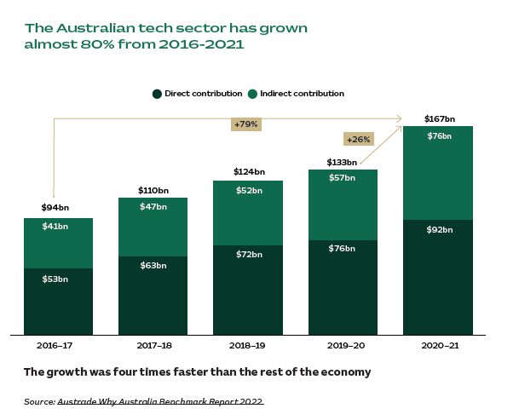

Venture capital turbocharged the startup ecosystem

Australian innovators and local tech startups attract global investors. In 2022, Australia showed great resilience despite the global slow-down. Our startup ecosystem is flourishing and early-stage deal activity was stronger than ever.
- Australia attracted A$7.4 billion
- Australia saw 712 deals in 2022
- 5 new unicorns in 2022
- A$1.2 billion raised by Enterprise/ Business Software
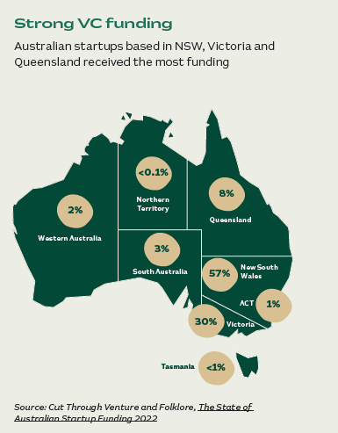

Australia’s tech start-up ecosystem
Australian tech giants and unicorns are attracting billions of dollars from global investors.
- 21 technology start-up companies reached “unicorn’ status (valued at over US$1 billion) as of Oct 2022
- Our fastest-growing tech powerhouses continue to invest and scale for global success.
- Australia produced 20,000 tech startups. Our creativity powers an innovative and connected tech ecosystem.

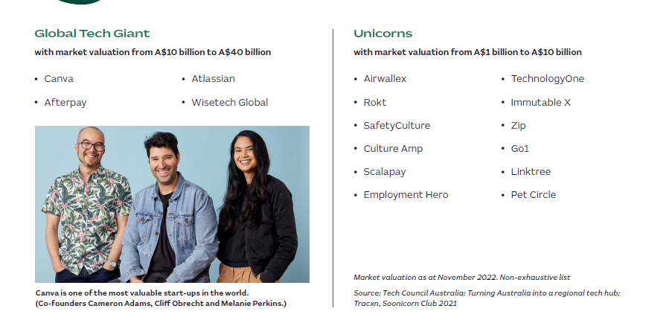

Our advanced, life-style cities are hubs for tech creativity
Australian universities and institutes partner with business to create innovation precincts. Tech hubs power industry clusters — in medicine, advanced manufacturing, mining and agriculture.

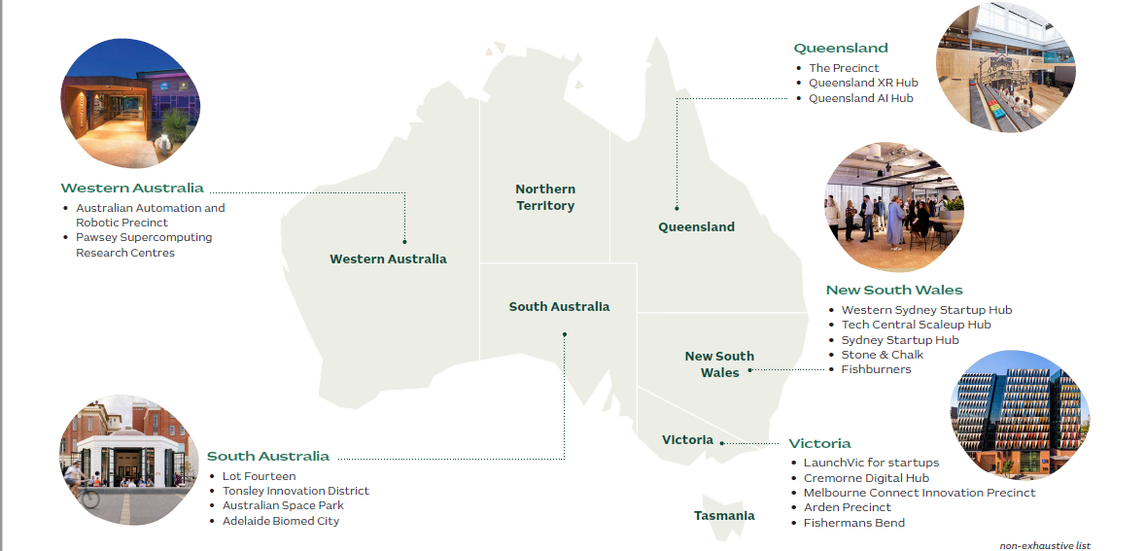

Advanced and stable digital economy
Australia is the world’s 12th largest economy

Our resilient economy is a magnet for foreign direct investment. Over 70% of our trade is with fast-growing economies in the Asia-Pacific region. We are a springboard for regional business expansion thanks to location, trade ties and language skills.

Australia was the world’s 12th largest economy in 2021. Nominal GDP was around A$2.2 trillion (US$1.6 trillion) in 2021. Australia was home to just 0.3% of the world’s population, but accounted for 1.7% of the global economy.
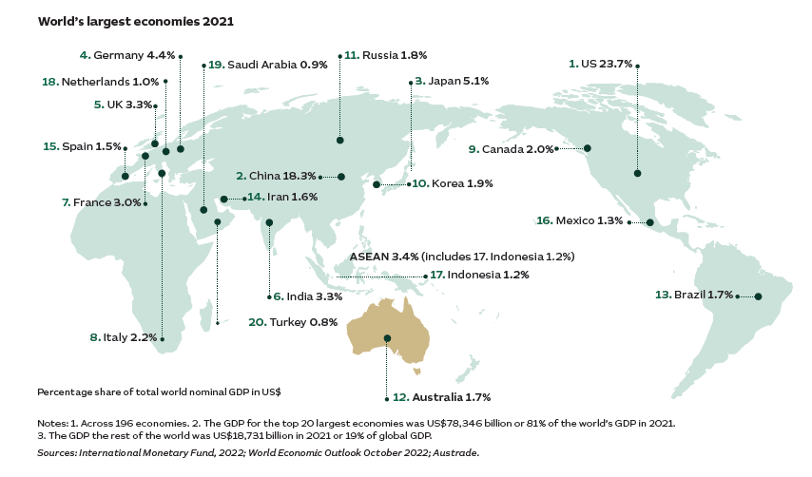

- Ranked 2nd for the most resilient economy during the COVID pandemic*
- Ranked 8th in Top FDI Destination Countries**
- Sydney 4th Top FDI Destination**
- Melbourne 10th Top FDI Destination**

A strategic location for Asia-Pacific expansion
Austrade facilitated A$7.4 billion FDI projects, creating 22,000 jobs in 2022. Our winning factors are our geographic edge and trade links with the fast-growing APAC region. (Source: Austrade’s Trade and Inward Investment Results 2021-2022 Geopolitical)

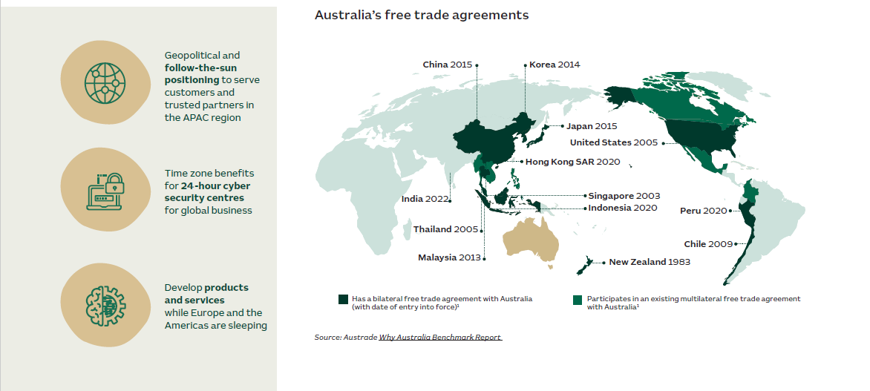

Investors benefit from advanced digital infrastructure
Australia ranks in the top 10 nations globally for 5G connected devices, data centres, telecoms investment and digital cities. Our infrastructure is intelligent and conducive, leading to greater opportunities for investment.

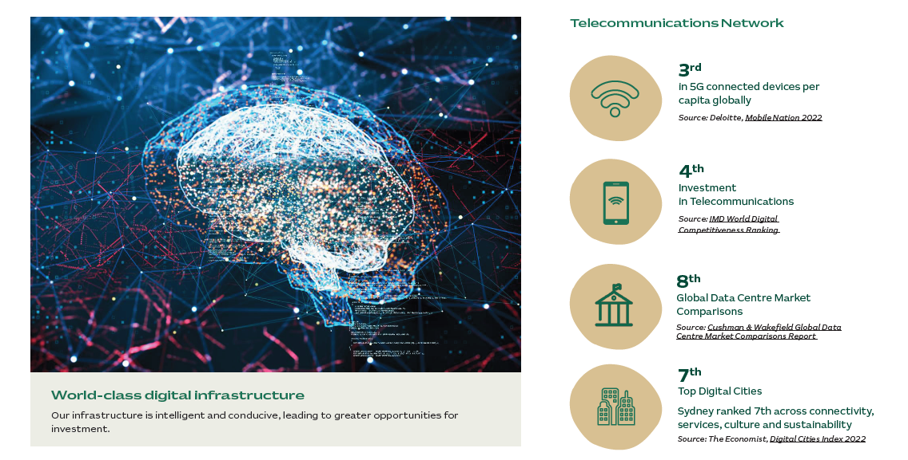
Australia is a solid and reliable foundation for overseas investors

We score highly in rankings that investors care most about. Our regulatory frameworks are transparent and business-friendly. Our legal systems protect IP.
- Our stable regulatory environment
  - Australia compared well in regulatory stability – ahead of developed economies such as Germany, Singapore, Japan, UK, and US. Source: Austrade Why Australia Benchmark Report

- Australia ranked the 5th most powerful cyber nation. We were ranked
  - 1st for Defence
  - 4th for Intelligence
  - 8th for Commerce
  - 8th for Norms
Source: National Cyber Power Index Report 2022 by Harvard University

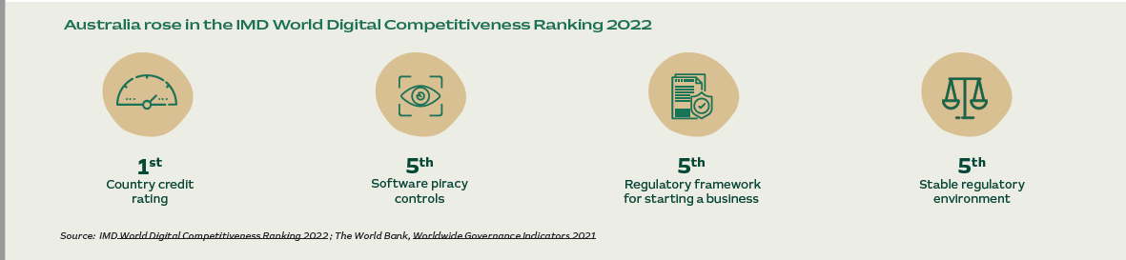

One of the world’s top countries for digital readiness
Australia invests heavily in digital capabilities. The result: we reached our highest stage of digital readiness. Australia ranks 6th globally for human capital, and 9th for startup-friendly environment.
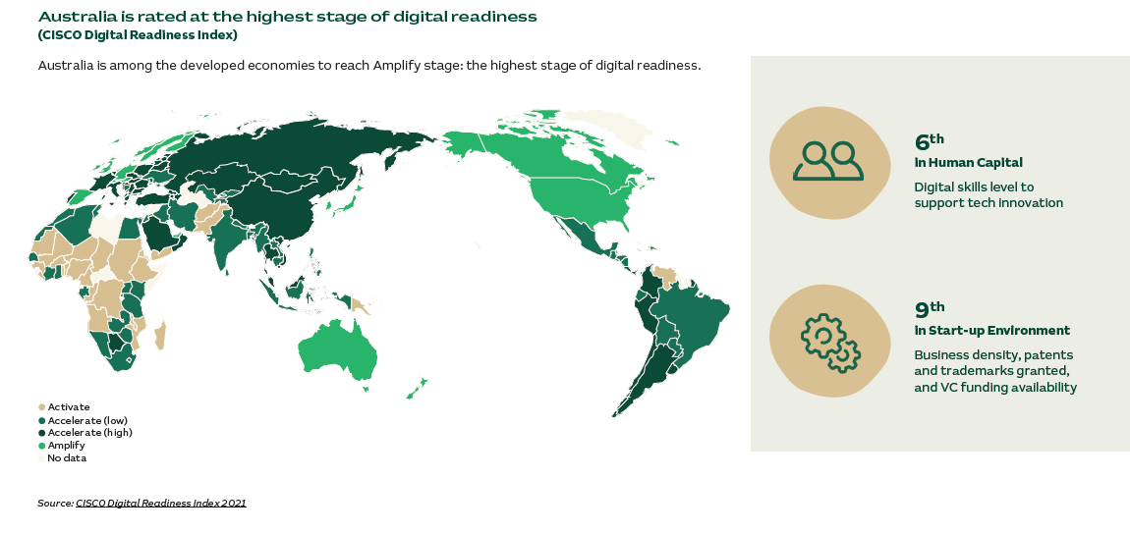

A nation of digital adopters

Australian businesses are big IT spenders

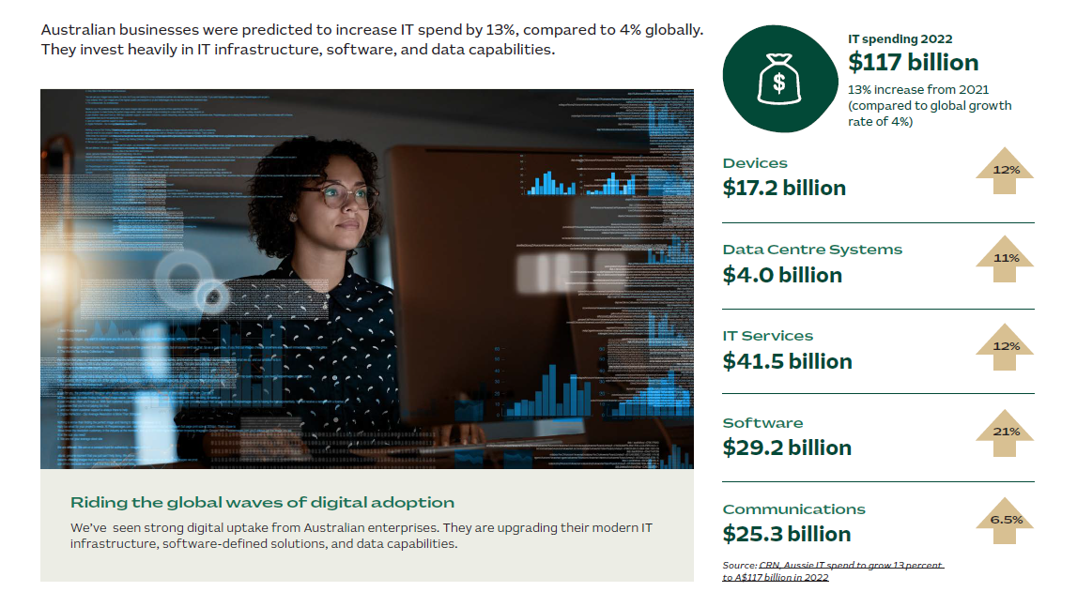

A nation of early adopters
Australia ranks 4th as the world’s most attractive online consumer market. We shop online, we love mobile broadband, and we helped pioneer buy-now-pay-later technology.

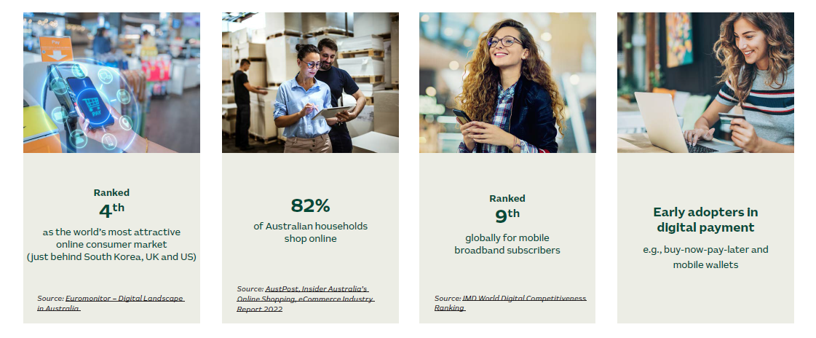

Talented and diverse workforce
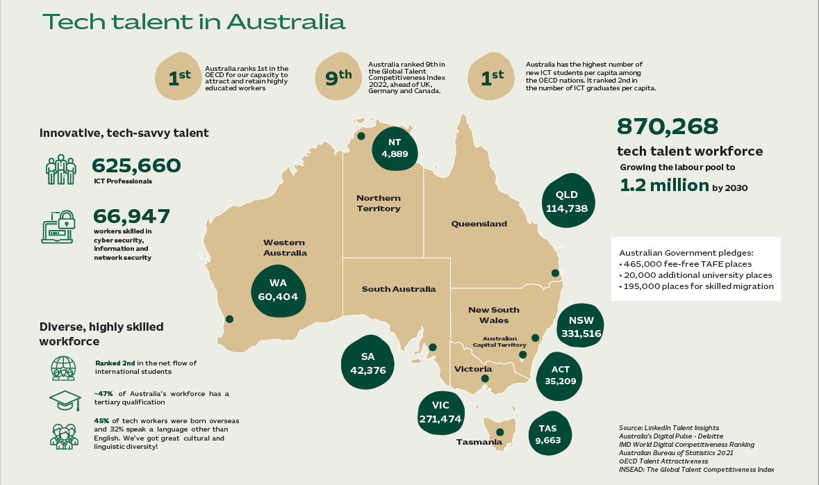
The Australian Government pledged to grow the tech jobs to 1.2 million by 2030. It has committed:

- Australia ranks 1st in the OECD for our capacity to attract and retain highly educated workers.
- Australia has the highest number of new ICT students per capita among the OECD nations. It ranked 2nd in the number of ICT graduates per capita.
- Australia ranked 9th in the Global Talent Competitiveness Index 2022, ahead of UK, Germany, and Canada.
- Ranked 2nd in the net flow of international students.
- ~47% of Australia's workforce has a tertiary qualification.
- 45% of tech workers were born overseas and 32% speak a language other than English. We've got great cultural and linguistic diversity!

Government driving digital transformation

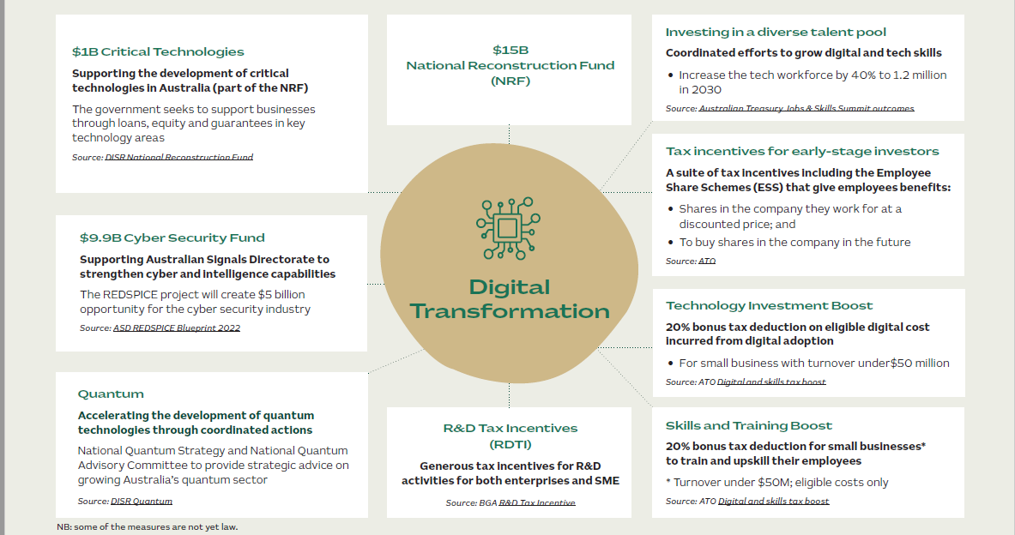
Tech is a priority sector for R&D support

Australia’s state and territory governments partner with industry to incentivise R&D in technology. Meanwhile, global tech is a keen investor in Australian technology hubs, thanks to high skills availability.

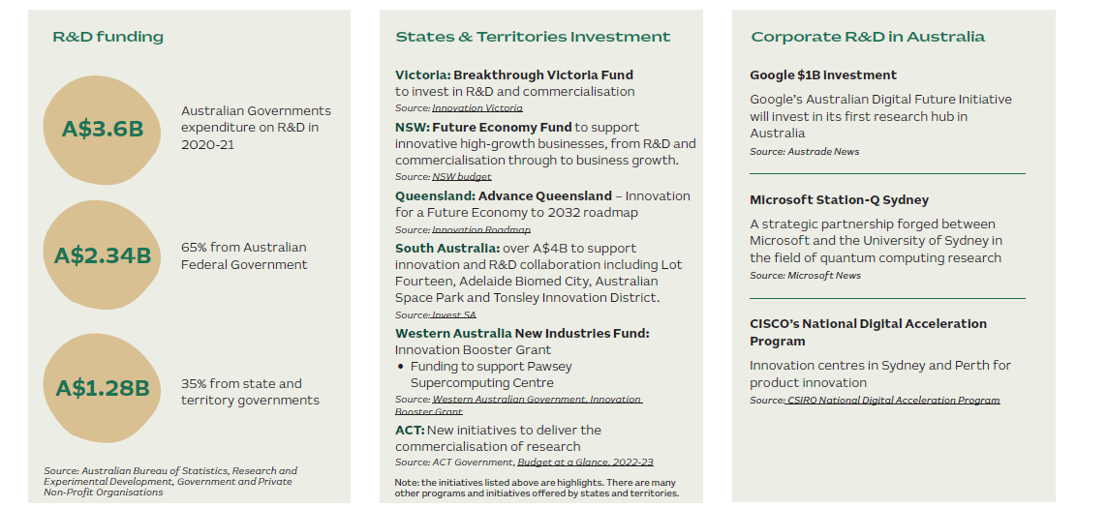

R&D excellence in multiple fields of technology

Australia attracts top-grade academic researchers. The Commonwealth Scientific and Industrial Research Organisation (CSIRO) helps focus investment in deep-tech and future-critical industries.

The University of Melbourne, the University of Sydney, the Australian National University, UNSW, and University of Queensland are in the global top 50 universities.

- TOP 1% of the world’s scientific institutions in 15 of 22 research fields
- CSIRO is Australia’s national science agency. It has leading research expertise and capabilities across science and tech.
- Data 61 is CSIRO’s data and digital specialist arm. Its National AI Centre leads Australia’s AI adoption and development.

Opportunities across the technology landscape
Australia’s 800 fintech companies create a global hub
Australia now ranks 2nd in the Asia-Pacific as a fintech hub, and 6th globally. We are great fintech innovators – thanks to our outsized, A$10 trillion financial sector and consumers who are early fintech adopters.

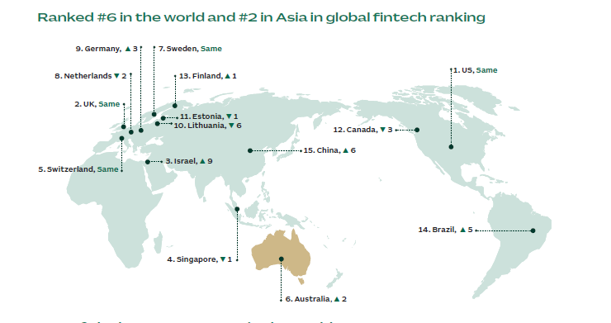

Australia has one of the best ecosystems in the world:

- 800+ Fintech companies A$4+billion industry
- 160+ Fintech companies in Australia are foreign owned
- Global fintech hub ranking:
  - 11th – Sydney
  - 25th – Melbourne
Source: Findexable, Global FintechRankings, 2021

Australia offers exceptional opportunities for global businesses:
- Growing domestic demand and policies that encourage innovation
- Financial institutions are looking for innovative solutions and partnerships to transform Australia’s A$10 trillion financial services industry
- A stable regulatory environment with policies that encourage innovation including an Enhanced Regulatory Sandbox and Consumer Data Right (Open Data)
- Australia is a strategic location to capture the growth of fintech in the Asia-Pacific – e.g. Australia-Singapore Fintech Bridge
- Clear pathways to enter the Australian market
- Forging alliances and investment partnerships with large banks, incumbent institutions and start-ups to solve customer problems
- Tapping into opportunities from rapid adoption of digital platforms and payments solutions by businesses and consumers

A global leader in 5G rollout

Australia will have 95% population coverage for 5G by 2025. We have the infrastructure and capabilities to be a test-bed for 5G innovation — in mining, healthcare, transport, utilities, and other industries.

Benchmarking 5G development in Australia
- 3rd globally connected devices on a per capita basis
- 95% connected devices on a per capita basis
- 7th / 65 countries Most extensive 5G Subscriber uptake, latency and speed
- 4,000+ Operational 5G base stations deployed as at 2021
Sources: Deloitte Mobile Nation 2022; Telstra, T25 Strategy; Mobile Magazine 2022

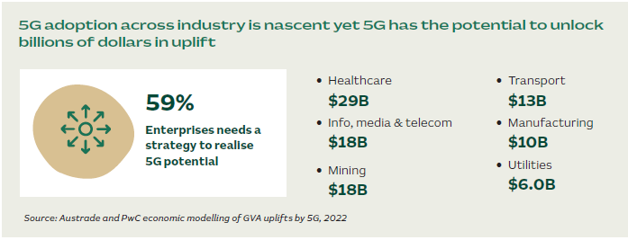
Strong government support for regional connectivity (AUD)

- Australian Government $210M
- Victorian StateGovernment $550M
- NSW Government $400M
- Government of Western Australia $48.6M

Market entry pathways

- Co-invest with domestic industries and telco companies to accelerate 5G innovation such as signal propagation and slicing
- Use Australia as an OECD-market test bed for 5G-enabled innovation

World’s 2nd biggest FDI market for cyber security
Australia is a big supplier of cyber security technologies. We are a big consumer as well, with a growing cyber market driven by regulation. Defence alliances with the US, the UK, and neighbours in Asia-Pacific require best-in-class cyber skills.

- Australia delivered the world’s 9th largest revenue in cyber, growing at 11% per year to 2026 Source: AustCyber, Australia’s Cyber Security Sector Competitiveness Plan 2022
- 60% of Australian companies will increase cyber budgets in 2023 Source: PwC, Cyber Security Digital Trust 2022
- World’s 2nd largest FDI market in cybersecurity (2017-2021) Source: FDI markets analysis 2022
- World’s 5th Most Powerful Cyber Nation

Strategic location to grow global cyber operations

- Regional leader in global alliances
- AUKUS pact – Australia, the UK, the US
- QUAD – Australia, the US, India and Japan
- 24-hour cyber security centres

Co-investment opportunities

- Uplift national security and critical infrastructure with Australian Cyber Security Centre (ACSC) and Australian Signal Directorate (ASD)
- Invest and co-design solutions with Cyber CRC
- Leverage AustCyber and CyRise’s accelerators
- Co-develop solutions with CSIRO and universities

Evolving regulatory framework
- 2,000+ Critical Infrastructure entites to comply with Security of Critical Infrastructure ACT (SOCI)
Source: Australian Financial Review (AFR)
- A$5 billion REDSPICE imitative opens opportunity for the industry
Source: ASD, REDSPICE Blueprint 2022

Tax incentives power a smash-hit digital games industry
Overseas investment partners with our creative nous, triggering a renaissance in digital games creation right across Australia. Government support helps. The Federal Government will offer a 30% tax offset incentive. State-level support can take this to 40-45%.

Australia’s capabilities
- A creative and connected ecosystem
- Australia’s smash-hit games rocketing up global sales charts and winning critical acclaim
- IP creators: 74% of Australian game developers create their own IP

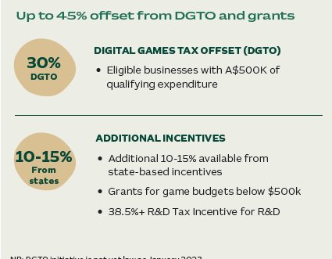
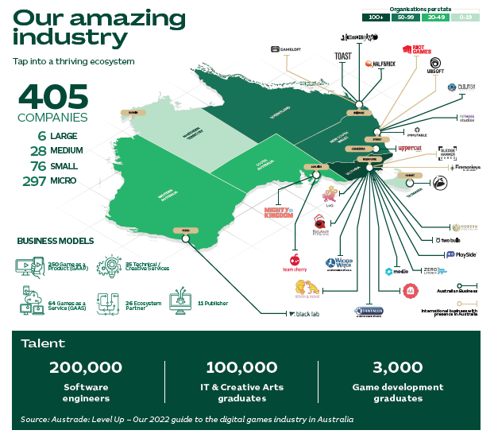

Australia’s rapid uptake of digital services

Almost half of our top digital services companies are foreign-owned, ensuring Australia’s digital economy reflects world-leading solutions and our workforce is globally competitive.
- Australia recorded healthy domestic growth A$117 billion
- IT spending in 2022, 13% increase from 2021 (global growth rate was 4%)
- A$41.5 billion for IT Services spending ~35% of the total IT spending
Source: CRN, Aussie IT spend to grow 13 percent to A$117 billion in 2022

Australia’s foreign direct investment 2019-21
- Ranked 4th in attracting FDI in Software & IT Services globally between 2003-2020

FDI in Digital and IT Services significantly contributes to Australia’s employment
- 45 out of 100 top digital services companies in Australia are foreign owned
- 69% employees are hired by foreign investors in top 100 digital service companies
- 38,595 estimated number of employees hired by top 10 foreign investors

Investors power rapid growth in quantum technology

Australia has 30+ years of global leadership in quantum research. Eight universities are performing quantum physics research well above world standard. We have a track record for growing university spinoffs.

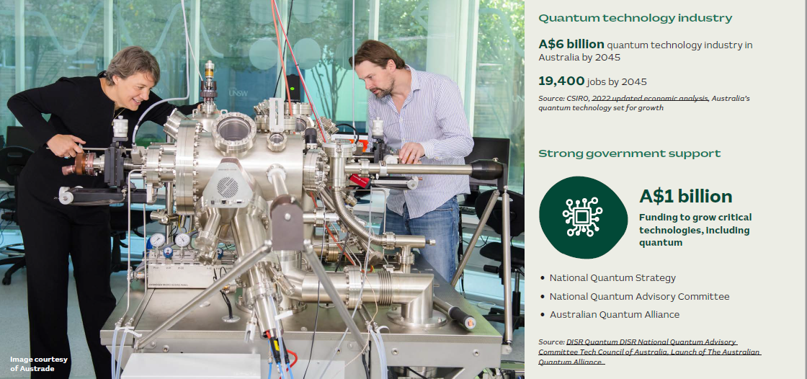

Centres of excellence and research institutions driving global collaborations

- Centre for Quantum Computation & Communication Technology (CQC2T)
- Engineered Quantum Systems (EQUS)
- Sydney Quantum Academy

- Australian Quantum Software Network
- CSIRO
- Pawsey Supercomputing Research Centre
- Centre of Excellence in Quantum Biotechnology

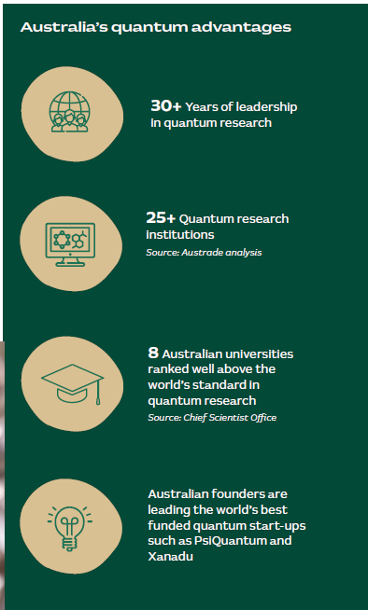

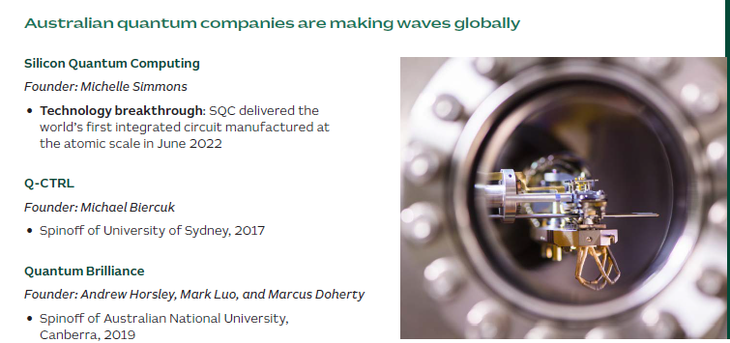

Austrade Services
